Nathan Flack

CPSC 455

Final Project

Complex Iterative Map

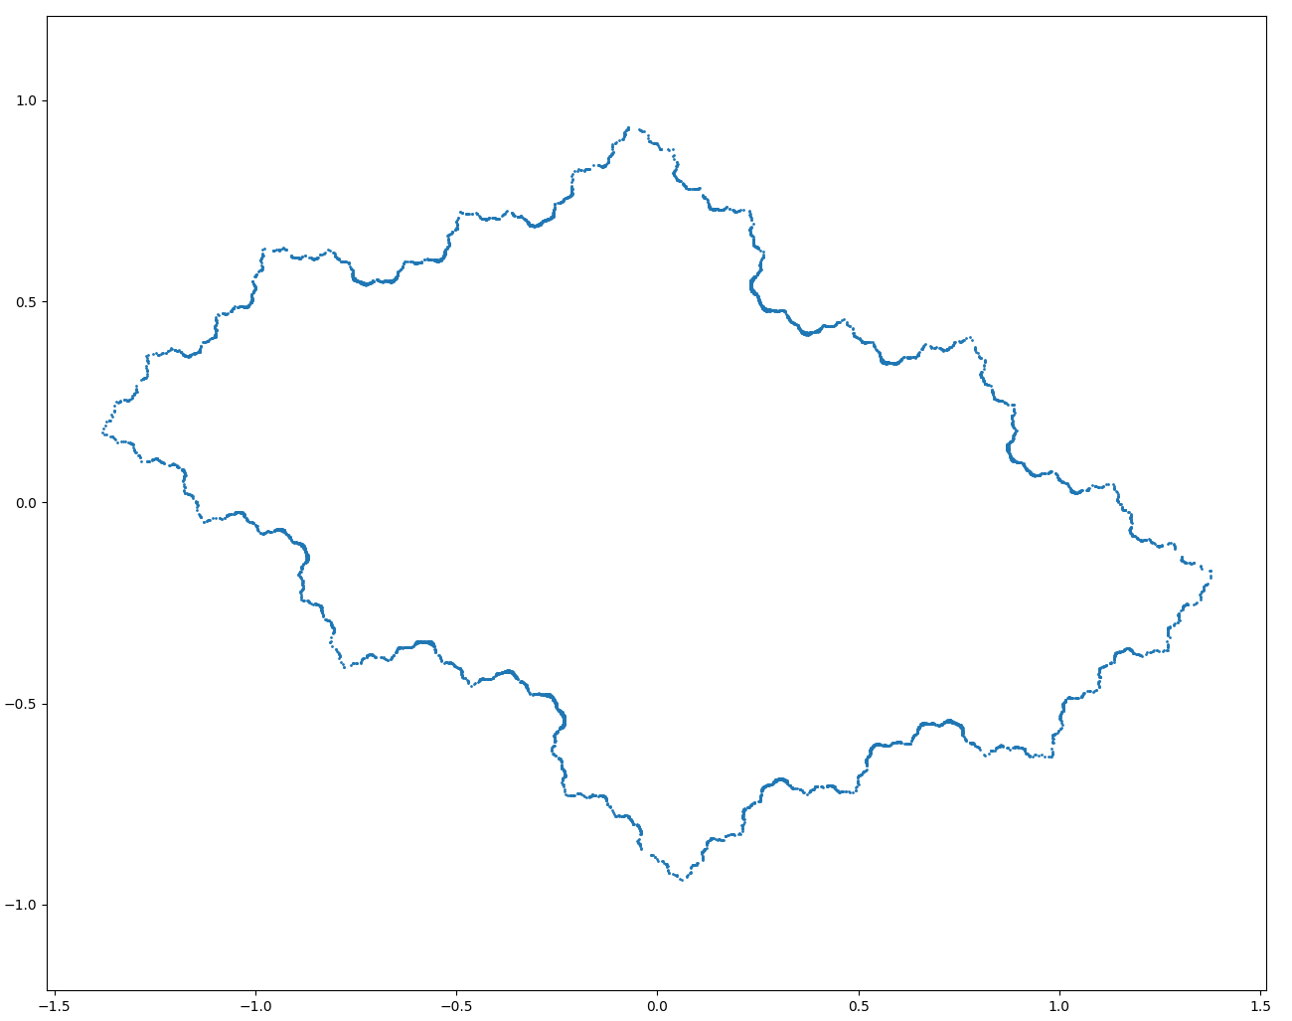

Consider the Julia set given in Figure (1). Take the mapping zn+1 = z2n + c where c = −0.5 + 0.3i

(a) Iterate the initial point z0 = 0 + 0i for 500 iterations and list the final 100. Increase the number of iterations. What can you say about the orbit?

Final 100 iterations after 500 iterations:

-0.38254595+0.16996282j

-0.38254595+0.16996282j

-0.38254595+0.16996282j

…

…

…

-0.38254595+0.16996282j

-0.38254595+0.16996282j

-0.38254595+0.16996282j

Final 100 iterations after 5000 iterations:

-0.38254595+0.16996282j

-0.38254595+0.16996282j

-0.38254595+0.16996282j

…

…

…

-0.38254595+0.16996282j

-0.38254595+0.16996282j

-0.38254595+0.16996282j

The orbit is attracted to the fixed point at -0.38254595+0.16996282j

(b) Iterate the initial point z0 = −1 − i and list z1 to z10. What can you deduce about this orbit?

-1.0-1.0j,

 -0.5+2.3j,

 -5.54-2.0j,

 26.1916+22.46j,

 181.04831056+1176.826672j,

 -1352143.02517396+426125.26157509j,

 1.64670802e+12-1.1523646e+12j,

 1.38370314e+24-3.79521606e+24j,

 -1.24890306e+49-1.05029047e+49j,

 4.56648772e+97+2.62342198e+98j

This orbit increases to infinity as it iterates.

2. Given c = −1 + 1, determine the fixed points of periods one and two.

2a. fixed points

z^2 - 1 + 1i = z

z1= -0.693897202308099 + 0.418796525390441i

z2= 1.6938972023081 - 0.418796525390441i

2b. period two

(z\*\*2 - 1 + 1i)\*\*2 - 1 + 1i = z

Z3 = -1.30024259022012 + 0.624810533843827i,

Z4 = 0.30024259022012 - 0.624810533843827i,

3. Plot the Julia sets for

(a) c = 0 + 0i,

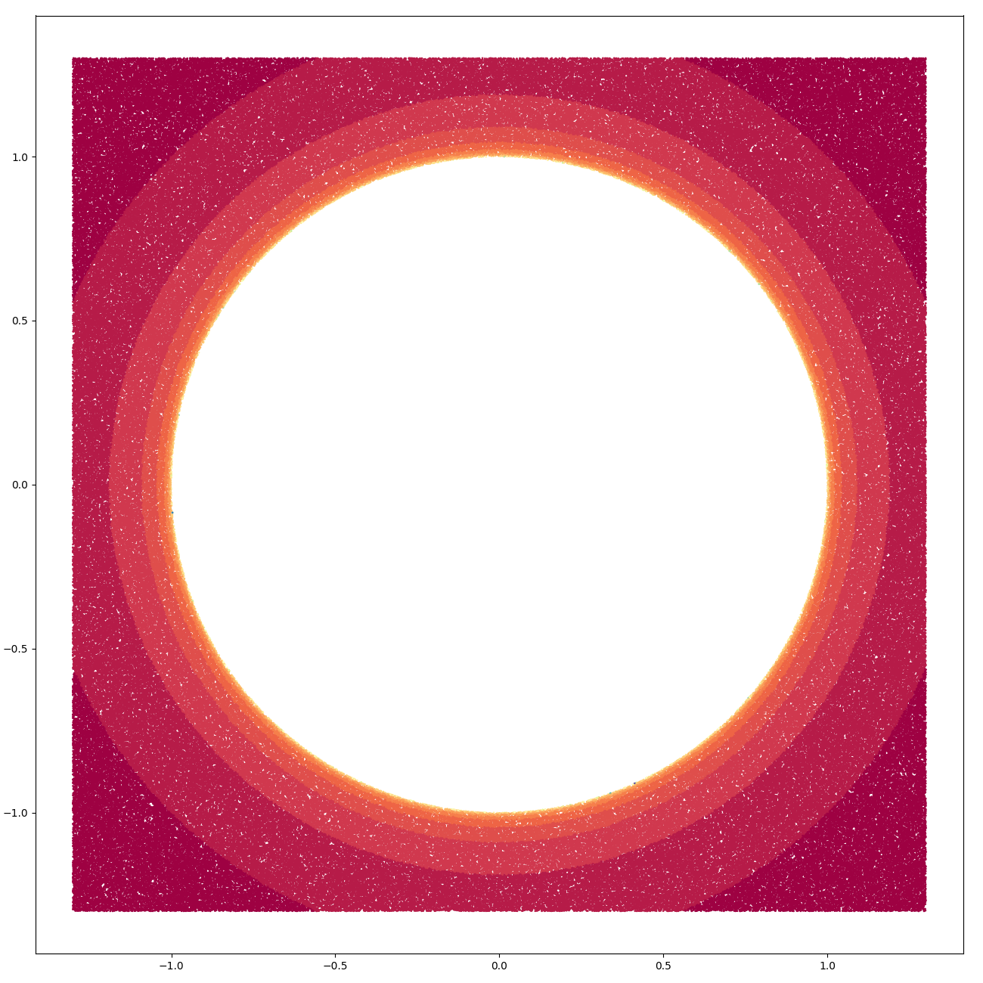

(b) c = −0.5 + 0i,

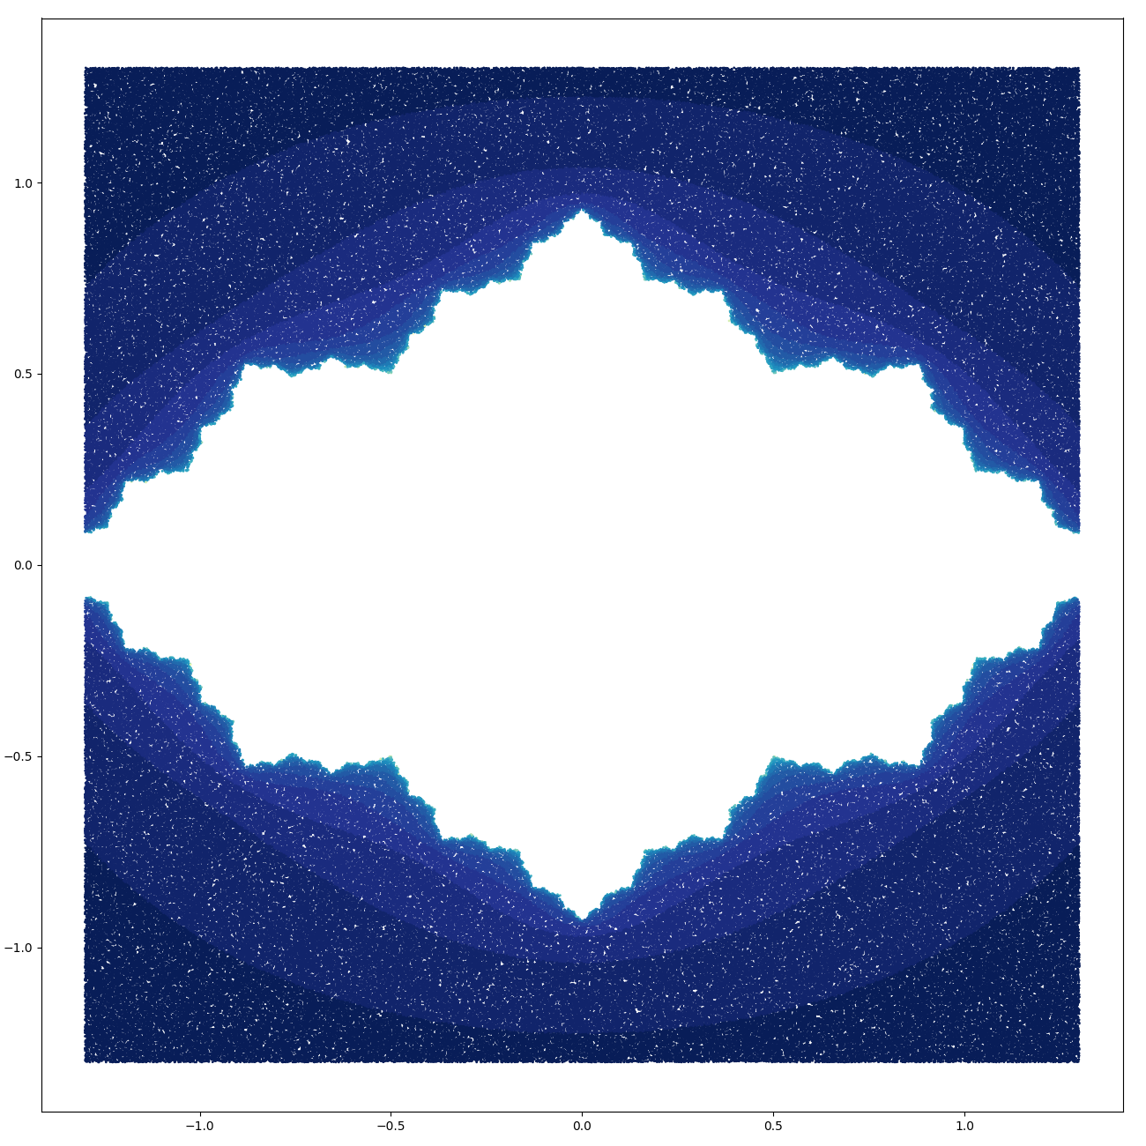

(c) −0.7 + 0i,

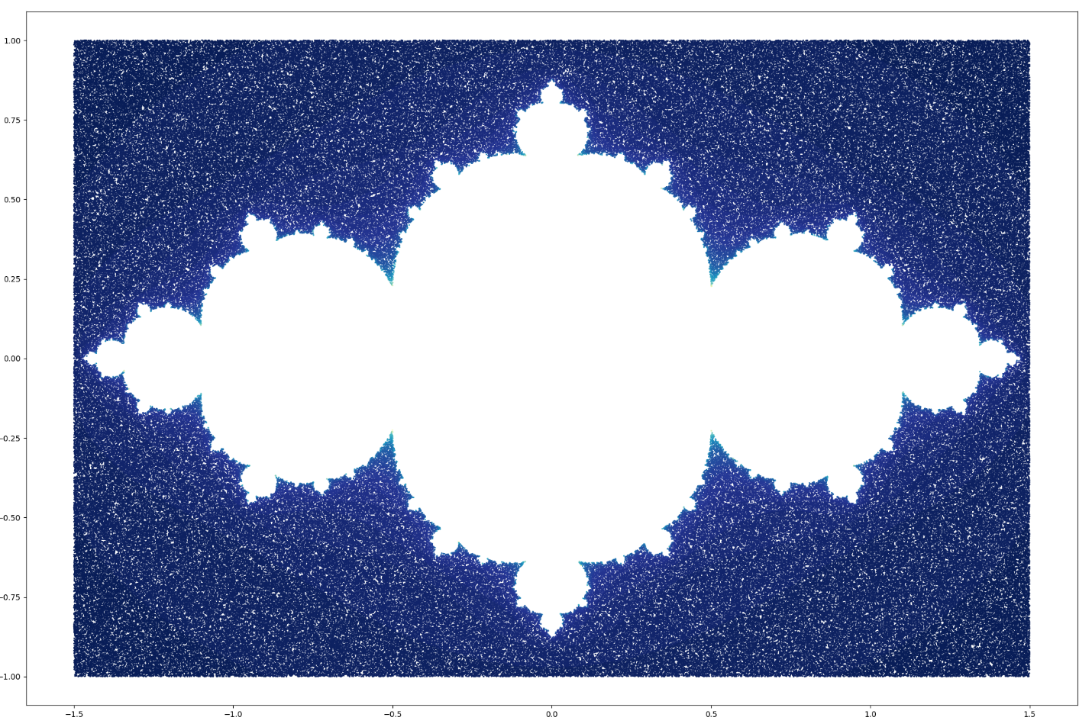

(d) −2 + 0i.

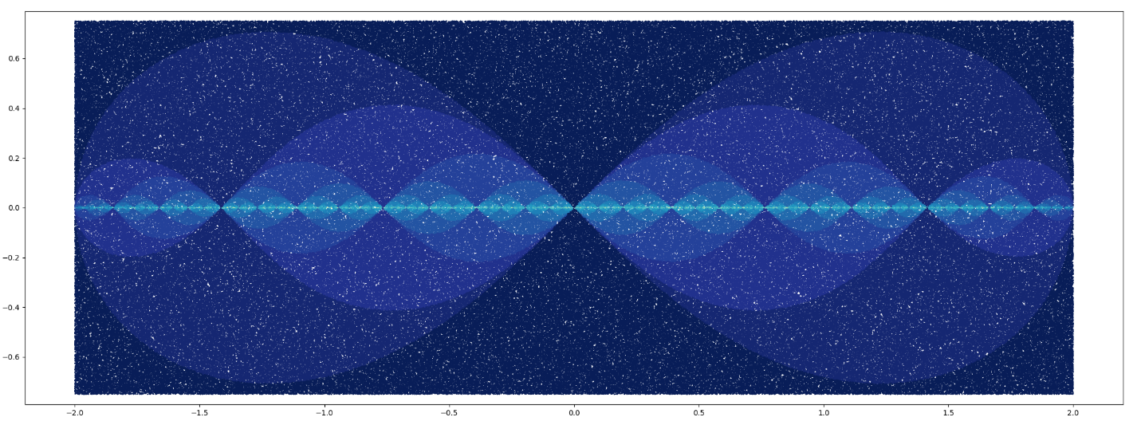

4. Compute the fixed points of period one for $z_{n+1}=2+\frac{ze^{i{|z|}^{2}}}{10}$

$$2+\frac{ze^{i{|z|}^{2}}}{10}=z$$

Z=1.80619 - 0.0211285i

5. Determine the boundaries of points of periods one and two for the mapping $z_{n+1}=c- z_{n}^{2}$

$$c- z_{n}^{2}=z$$

Period one:

$$z=\frac{1}{2}(±\sqrt{4c+1}-1)$$

Period two:

$$z=\frac{1}{2}(±\sqrt{4c-3}+1)$$

Additional plots: zn+1 = z2n + c

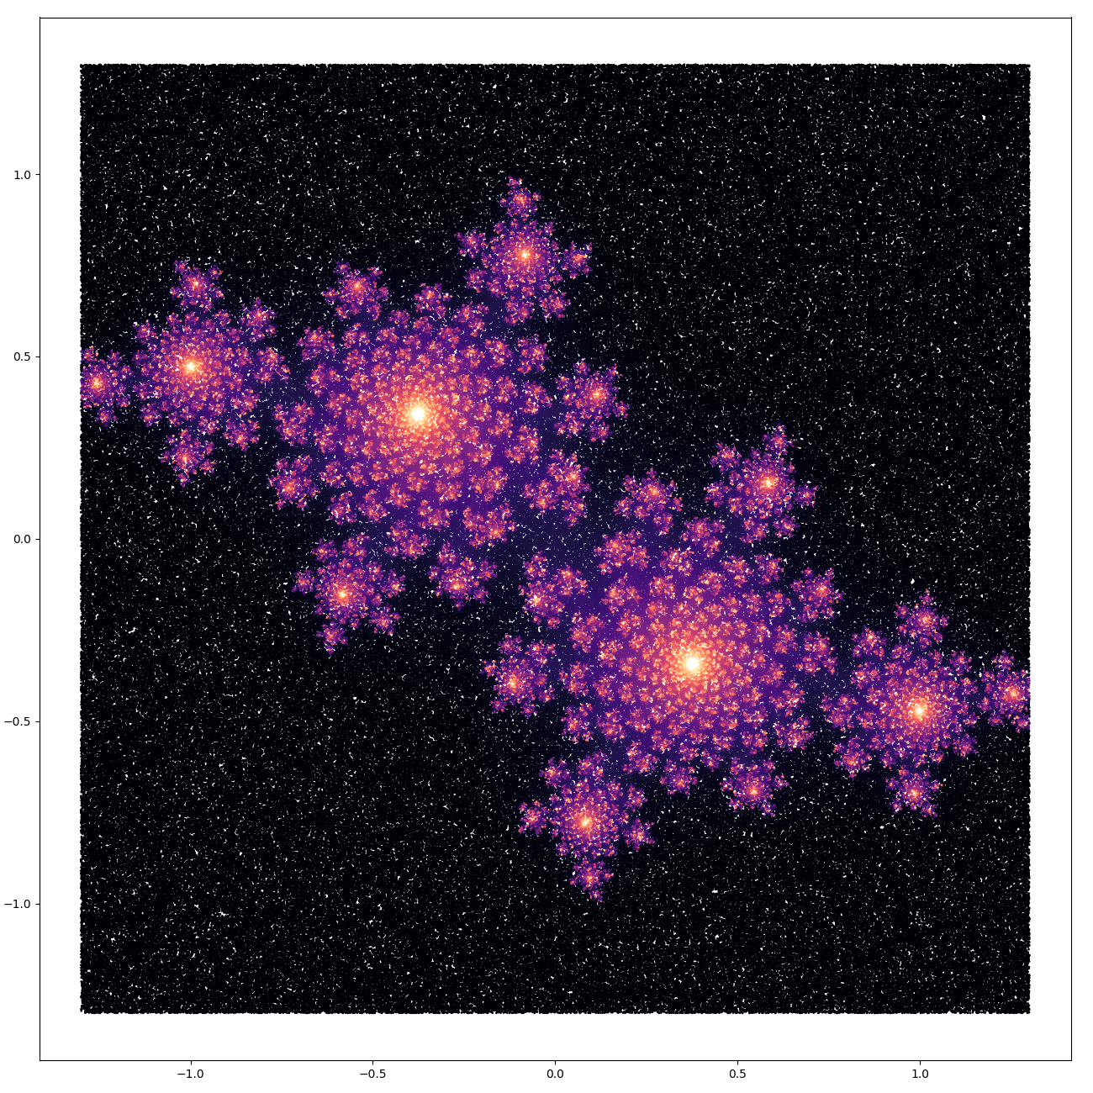

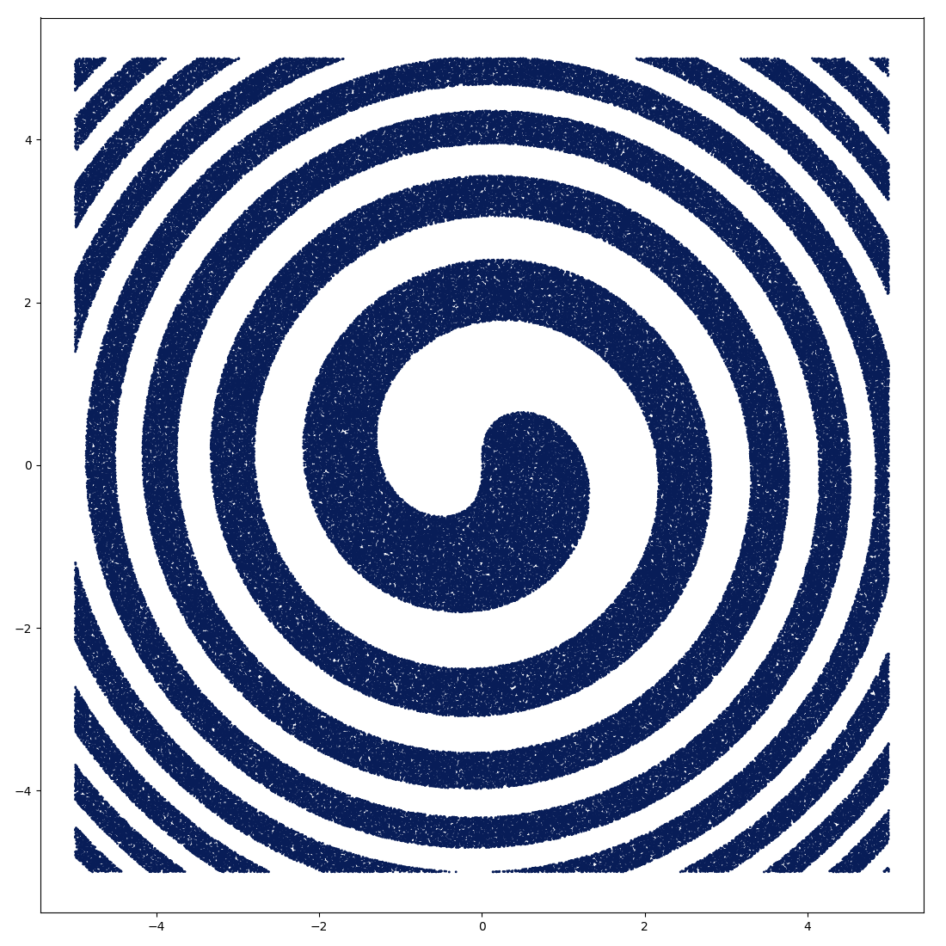

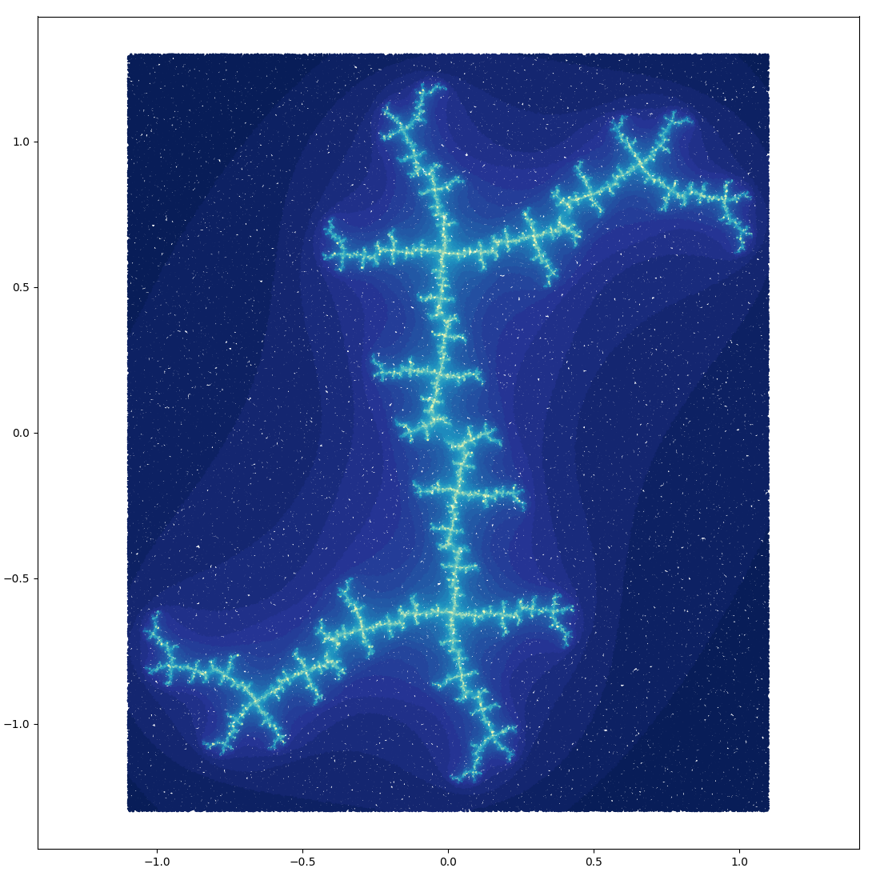

zn+1 = z2n + c

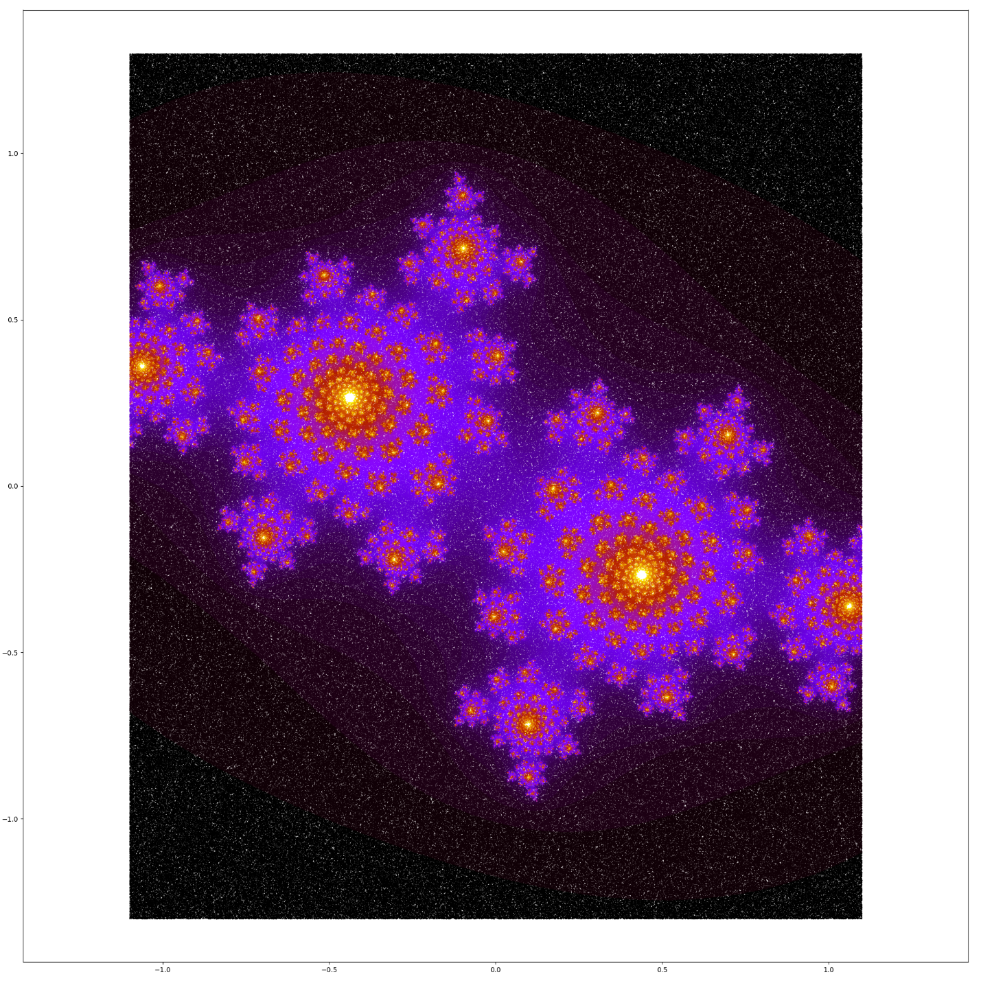

Basin of attraction for $$z_{n+1}=z_{n}^{3}+c$$

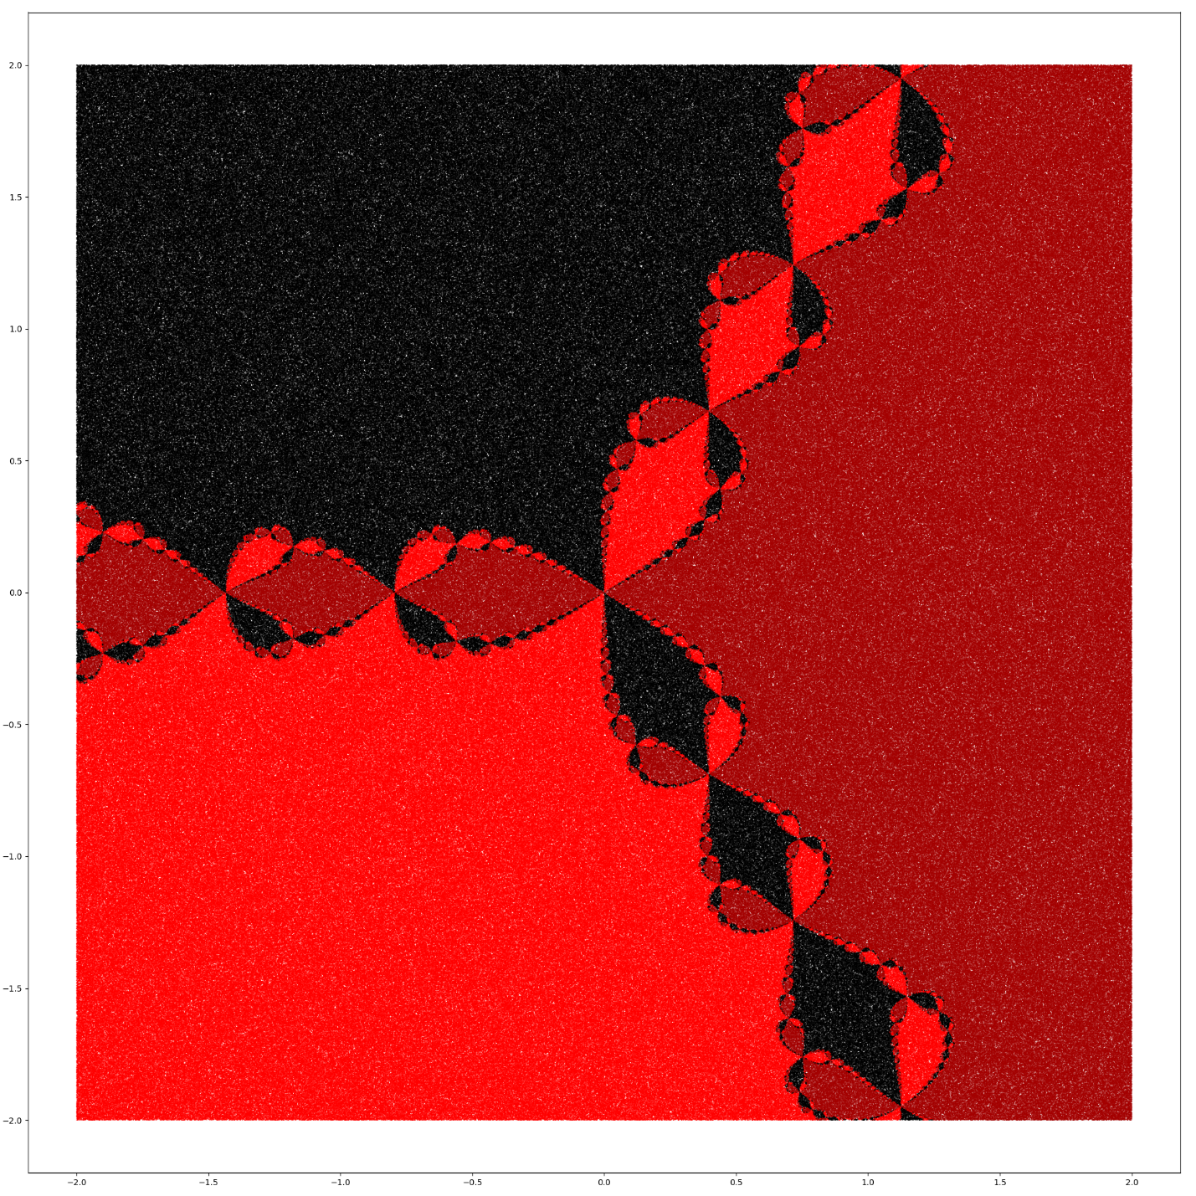

Basin of attraction for

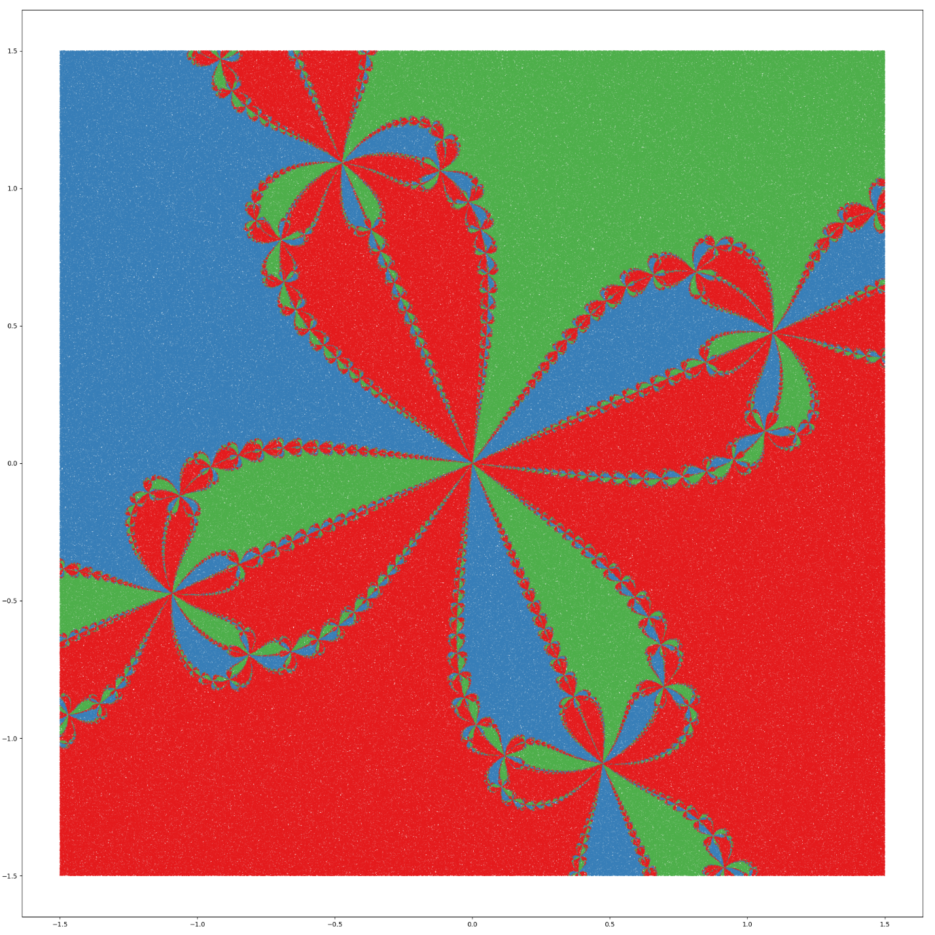

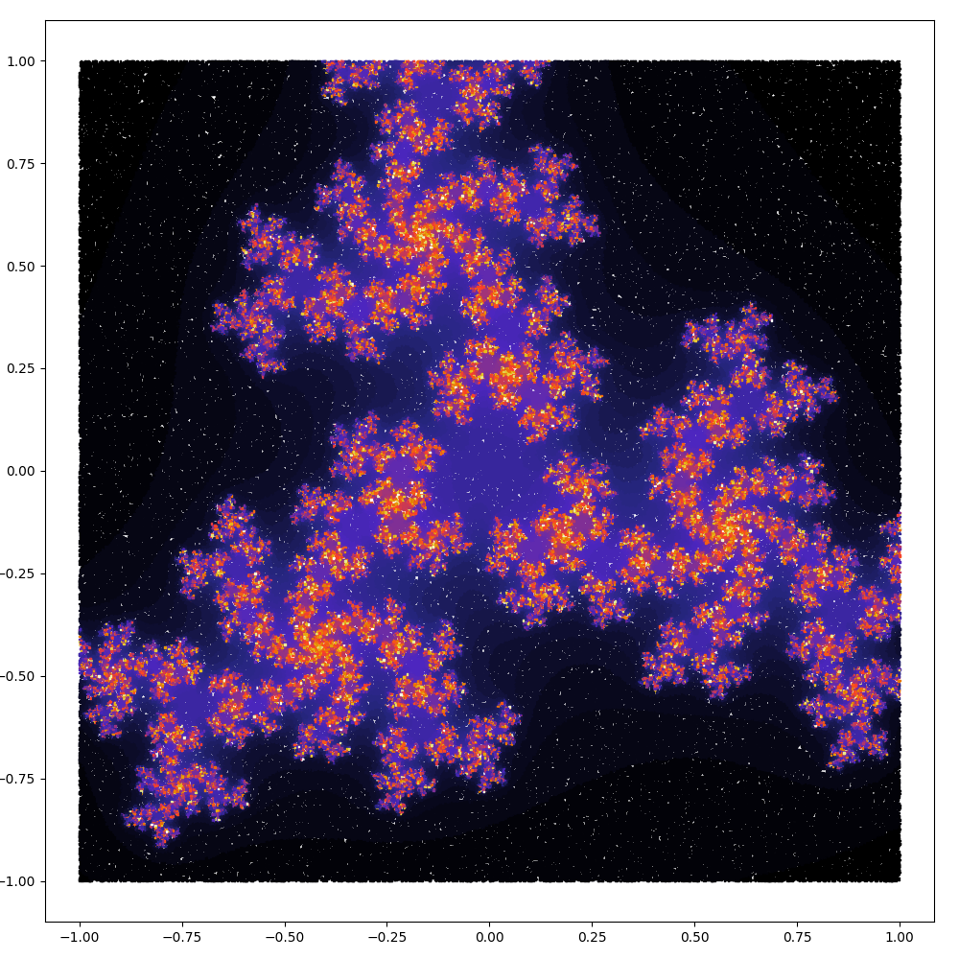

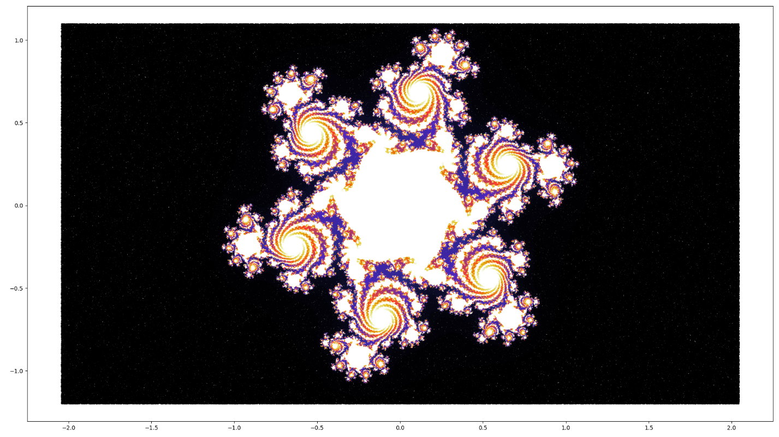

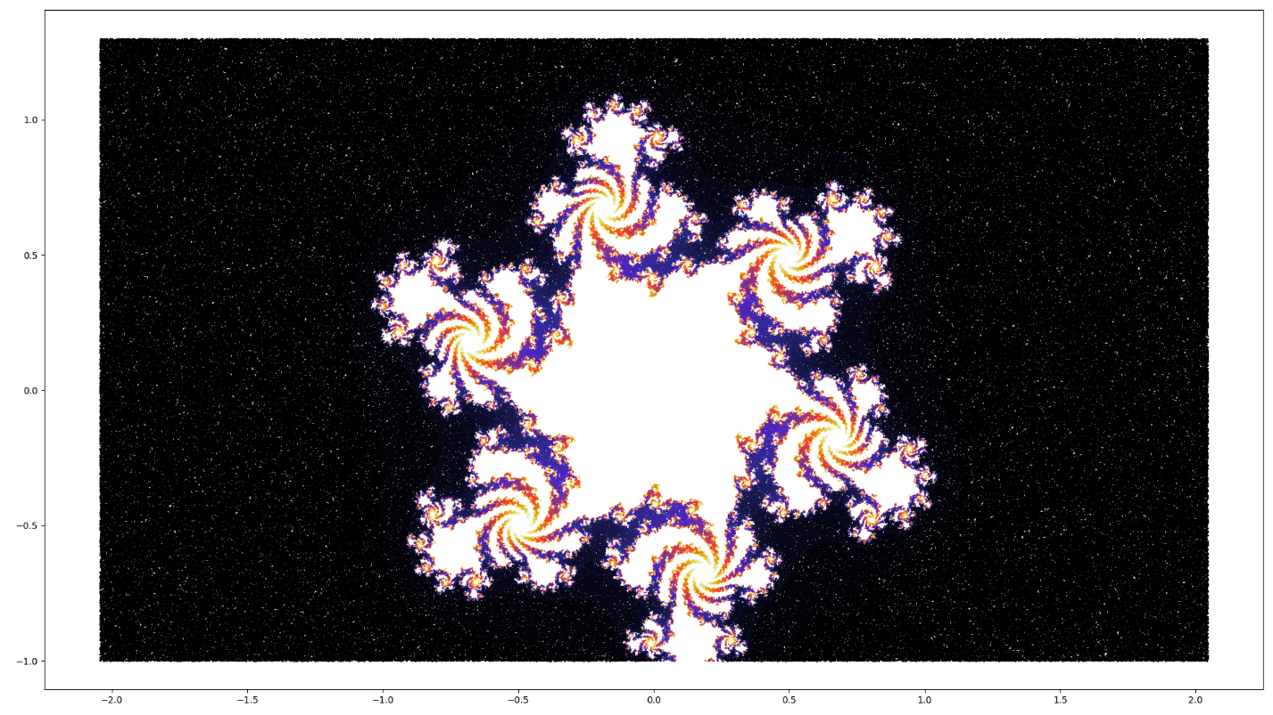

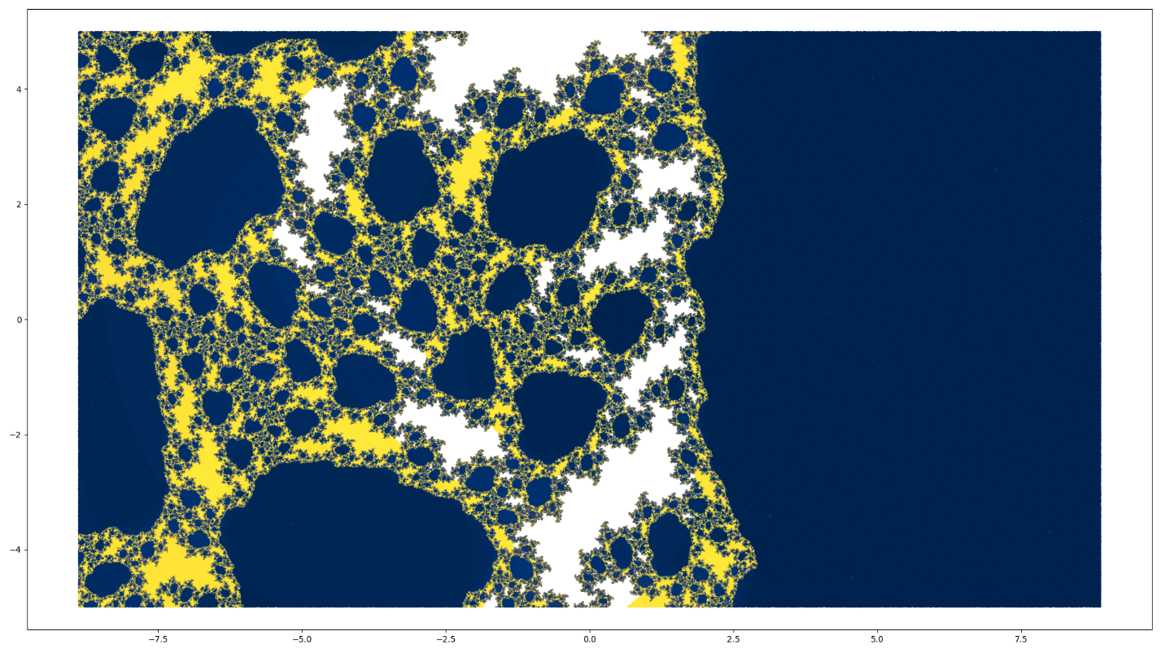

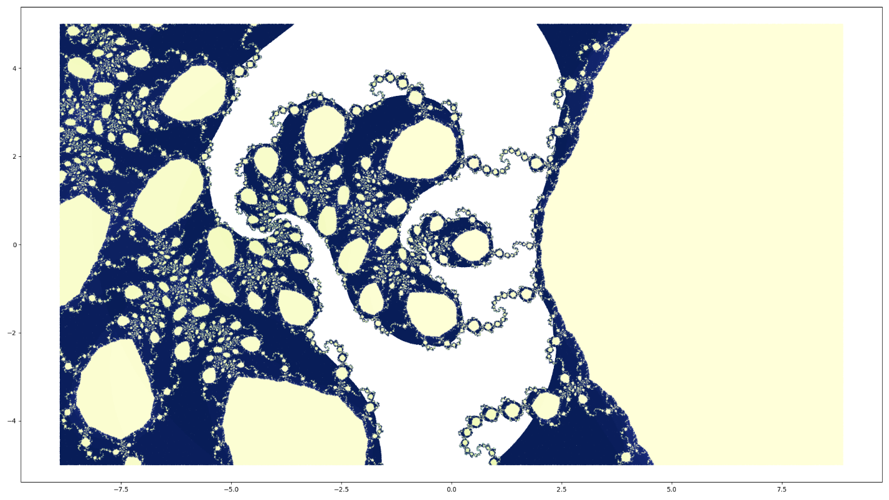

+ c

